**Stratotech Park Track Notes**



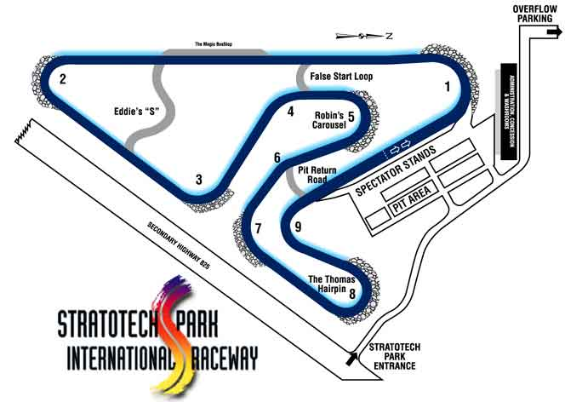

**Things to keep in mind when reading!**

- Recommended braking/turn in points and apexes are best used as a starting point or guideline. Your car and driving skill will dictate your best line. Be cautious with these guidelines until you are comfortable with the track.

- Track conditions can have a huge effect on what line is ideal and how you drive it, as can specific goals (fuel/tire/car management).

- This guide is best used in conjunction with an onboard video from a car similar to your own.

**Turn 1**

**Start/finish marshal station on right**

**Pit exit on right**

Get to the right edge of the track down the main straight, and use the braking markers and start/finish marshal station as braking references. More powerful or heavier cars will brake shortly before the marshal station, right around the “3” marker. Less powerful cars will be able to brake later, closer to the “2” marker.

Turn in after the “1” marker, right around the end of the pit divider wall and about a car length or two before the pit lane meets the track surface. The track becomes a little bit banked as you enter, but it doesn’t result in a noticeable amount of extra grip.

Use the dip in the track as an apex reference. Less powerful cars can apex right at the dip, more powerful or less grippy cars will want to apex just after. This dip is quite significant and can seriously upset the car, especially if you hit it at a slight angle, so you may need to ease off the steering slightly as you hit it to keep the car in line. Try to ensure you hit the dip square, as hitting it at an angle can be less predictable and generally results in a larger loss of grip.

One of the best tricks with this dip is to have your inside tires up on the curbing as you go over it. The curbing does not have a dip in it, which means that the dip will only affect 2 tires. This will help keep the car much more stable and allow you to carry more speed.

The track is quite wide on exit, so be sure to get on the throttle at the apex and use all that extra space. The track does lose its banking as you track across to the RH edge, so powerful cars will need a little bit of caution to prevent wheelspin as the grip is reduced.

**Turn 2**

Use the braking markers on the right as a reference. Powerful, heavy cars will brake around or even before the “4” board, while lighter, less powerful cars can wait until they are closer to the “3” board. Be sure to brake extra early the first couple laps if you aren’t familiar with the track, as there isn’t a ton of grip here, the corner is quite a bit tighter than it appears on video, and there is not much runoff area.

Turn in is just after the “1” board in less powerful cars, while more powerful cars will want to wait until about halfway between the “1” board and the turn in cone (keep in mind sometimes the turn in cone isn’t there, or has moved). The track gains some banking in this corner, and unlike T1 it gains you a noticeable amount of extra grip. Be sure to use this extra grip as it comes to get the car turned as you approach the apex.

There is not always an apex cone, when it is there it tends to be very late and is only usable as a direct marker for very powerful, lower grip cars. In less powerful cars, you can use it as a reference and apex a car length or so before it. Be sure to use all the curbing here! If there is significant rain the water can sometimes form puddles around the inside edge of the asphalt.

The exit is fairly tight, and the banking flattens out fairly quickly at about mid track, so be cautious in powerful cars, especially those with rear drive.

**Turn 3**

Flat out in low power, high grip cars. In more powerful cars the braking point is between the “3” and the “2” board. Turn in just before the “1” board, or about halfway between the “1” and the “2” in less powerful cars. There is a little bit of banking near the apex that provides some extra grip, so allow the car to carry some extra speed in and wait for the extra grip to carry it through.

Use the apex cone as a reference, powerful cars will want to apex at or just before it, while low power cars can apex a bit earlier. In either case, be sure to drive on the apex curbing.

Like T1 and T2, the track loses its banking on exit, though less drastically. You can exit all the way to the edge of the track in low horsepower cars that are able to get back to the LH edge of the track in time for T4. Higher horsepower cars may want to keep their exit just a little tighter so that they can set up for T4.

**Turn 4**

Slight brake needed in powerful cars, but most low power cars will need to at least lift a bit as well. Be sure to get as far left as you can before turn in. There is not really any good turn in markers, so look ahead at the apex to help determine your best line. Be sure to use the extra grip as you go up the rise to get some extra turning done before you lose that grip as you go over the crest.

There is an apex cone, which is in a good position to use as a reference. You can also use the crest as a second reference. Most cars will apex between these references, but tend to be closer to the cone.

The exit isn’t really a typical exit, because the T5 braking point is just after the T4 apex.

**Turn 5**

Brake shortly after the T4 apex cone, allowing the car to continue to track out the LH edge of the track for the turn in point.

Use the braking marker boards and turn in cone on the left as a turn in reference. The turn in cone is generally quite late, even powerful cars will turn in a car length or so before it. Less powerful cars will turn in earlier, but still well after the “1” board. The corner is banked slightly, but gradually flattens out throughout the corner. Use the little bit of extra lateral grip that you have from it during the first portion of the entry to get the car turned.

The apex cone is usually placed near the end of the apex curbing, which is very late for all but the most powerful and slippery cars. Less powerful cars can take an apex closer to the middle of the curbing and will be able to track out all the way to the far edge of the track. Very powerful cars will be closer to using the cone as a direct reference, but will mostly still apex a car length or so before it. These powerful cars may need to keep their exit tight and not track out fully, so that they can have more space to go through T8 without lifting. Only keep the exit tight if the car cannot drive through T6 without lifting when you track out fully.

**Turn 6**

Flat out in almost all cars. If the car cannot do this corner flat out, tighten your exit slightly in T5 to give yourself more space to set up and take a wider line. Keep the car away from the inside edge of the track by at least a cars width, or you will not have enough space to track out and set up properly for T7.

There is a bit less grip in this corner due to having a slight crest. Be sure to use the grip available before the crest so that you can be better set up for when the grip is reduced. The track is banked slightly after the crest, but you’ll be braking here so it’s best to not have to do too much turning.

Be sure to track out to at least ¾ track for the T7 turn in point. You can allow the car to track out all the way to the RH edge, but with how close these two corners are it often results in the car being pointed away from the corner at the turn in point, so there is more turning to do in T7 (which is much more traction limited than T6). If you find you can track out fully to the edge of the track and get your car parallel to the edge of the track by turn in, do it, but in some cars, it is difficult to do without sacrificing excessive time in T6.

Keep your eyes up as the braking point for T7 comes before you have a chance to straighten the car out fully.

**Turn 7**

**Flag station on right**

Brake before or at the “2” board, depending on how much speed you carry through T6. Low power cars will be able to brake later, but be cautious as you should be turning some and the track is off camber here.

Turn in at or just before the “1” board. Get some extra turning done during entry, as there is a bump near the apex that will require you to relax the steering slightly.

Use the apex cone as a reference. Most cars will apex just before the cone. Be cautious of a sharp bump just before the apex, especially in stiffly sprung cars. Like T1, it helps to have your inside wheels on the curbing when you hit this bump, though some cars may apex this corner too late to be able to do that.

On exit the track loses its banking, so be cautious as there will be a little less lateral grip available.

**Turn 8**

Most powerful cars will brake before the “2” board, though some less powerful cars may be able to brake at it.

Turn in just after the “1” board. There is typically a small wall of cones blocking the inside 1/3rd of the track, as there is a dip similar to T1. Aim to apex at the end of this wall with the car square to the dip as you hit it.

After the car settles after the dip, gradually apply throttle and keep turning to bring the car smoothly to the inside edge of the track for a second “apex”, still gradually applying the throttle as much as the tires will allow.

Allow the car to track out to at least ¾ track in more powerful cars, and keep turning to bring the car to the LH edge of the track for T9. Less powerful cars can often track out fully and still make it to the LH edge for T9. If you find that the speed you can carry through the corner isn’t enough to force you to use all the track, turn in a bit earlier and allow the car to track wider after the first apex at the cones, ignoring the second “apex”.

If the wall of cones is not present, you can turn in earlier, aiming to apex shortly after the dip. Unfortunately, the dip is too early for most cars to be able to take an ideal line and still get their inside tires on the curbing (as the bumps in T1 and T7 are), though low power cars can apex early without too much of a penalty. Powerful cars are often better to soak up the punishment of the dip by entering a bit wider and taking a later apex that allows them to use the extra power sooner on exit.

It’s worth noting that this is not the only usable line through this corner, and it may not even be the fastest for your car. Depending on how your car reacts to the dip, you may need to experiment with different approaches, but this is a good starting point and is the theoretical ideal line. This is the most challenging corner on the track for most drivers and usually requires some experimentation in any car unfamiliar to the track.

**Turn 9**

Almost all cars will have some straight-line braking here, though there are no good markers for braking points, so use the turn in cone as a reference.

Use the turn in cone as a reference, it is generally early for most cars, but can be used as a direct marker for very powerful cars. Less powerful cars will turn in at leas 2-3 car lengths before it. The entry to this corner is slightly uphill, so heavy trail braking is usually not required here as the slope will help you scrub speed.

There is an apex cone that you can use as a reference, though it’s often placed quite late and most cars will apex before it. There is quite a bit of space on exit so plan to track out wide.

On exit, less powerful cars that use an earlier apex will have the benefit of being able to use a little extra asphalt on exit where the pit return road meets the track, though the pit return road quickly ends so you cannot track out much more than an extra foot. More powerful cars will want to be careful as they approach their track out point, as the slight banking that is present throughout the mid corner flattens out and reduces grip slightly.

**Pit entry on right**

**Start/Finish flag station on right**