**Castrol/Rad Torque Raceway (CW) Track Notes**



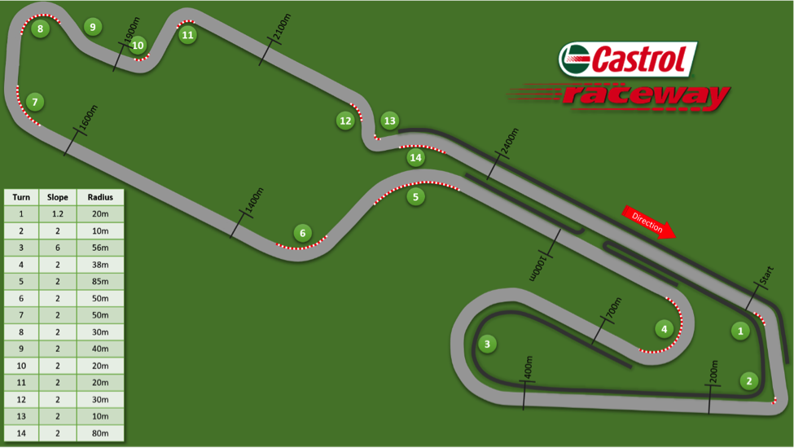

Photo credit: <https://www.apex-attack.com/>

**Things to keep in mind when reading!**

- Recommended braking/turn in points and apexes are best used as a starting point or guideline. Your car and driving skill will dictate your best line. Be cautious with these guidelines until you are comfortable with the track.

- Track conditions can have a huge effect on what line is ideal and how you drive it, as can specific goals (fuel/tire/car management).

- This guide is best used in conjunction with an onboard video from a car similar to your own.

**Turn 1**

**Marshal Station on RH side on entry**

Braking points will vary, but only the least powerful and grippiest cars will not have any straight line/threshold braking. A starting point for more powerful street cars will be the 300 marker.

Turn in shortly before the marshal station on the right side of the track, winding the steering in gradually while trail braking. Release the brakes and be back on throttle (lightly!) to balance the car over the bump at the apex.

Try to apex a bit away from the curbing, on or just after the surface patch, as the bump is worse close to the curb. How far away you choose to keep from the curbing will depend on how your car handles the bump (most stock street cars won’t have much issue with it, very stiffly sprung cars will be a bit upset). Due to the bumps the entry phase of the corner has the best grip, so do most of your turning early, and budget for a bit less grip across the apex and into the exit.

Allow to track out wide for T2, aiming toward the end of the tire wall, but your apex location and speed should not allow you to fully straighten the steering wheel before turning into T2. If you have space to drive in a straight line between the two corners, chances are you are not carrying enough speed through T1 and you should rethink your apex or evaluate how much grip you are actually using throughout the corner.

**Turn 2**

**Marshal Station on LH side on entry**

Braking zone has slight washboard and makes it easy to lock the brakes, though the washboard is a little better towards the left side of the track and as you get closer to the turn in point. The braking point for most cars will come before you fully exit 1, so be sure to roll onto the brakes a little more gently than usual.

The ideal turn in point can be a bit difficult to find (the kink in the asphalt towards the end of the gravel trap makes a good reference, less powerful cars car typically at or just before, more powerful/less grippy cars will turn in a little later). This corner doesn’t seem to react well to trail braking in most cars, and it’s typically best to let the car coast into the corner and scrub speed while using full cornering grip, or use a little bit of maintenance throttle to keep from scrubbing too much speed.

The track becomes on camber and has a slight compression around the apex curbing, so you can expect a little extra lateral grip there. Less powerful/stickier cars will apex early on the curbing, and more powerful/less sticky cars will aim closer to the middle of the apex curbing. The curb is quite aggressive (as most are at this track), so don’t run the curbing unless your car is very softly sprung. Deep puddles can form next to the apex curbing so be careful in heavy rain.

Road crowns on exit so budget your traction accordingly, use the extra camber and grip on the inner half of the track to turn, and be ready to lose some grip as you cross the crown and go onto the off-camber side of the track. Exit curbing is usable, but use caution because it’s fairly slippery and there are often deep holes in the dirt just beyond that can damage wheels and suspension.

**Turn 3**

**Marshall Station on LH side on entry**

Use the bike chicane as a brake marker (more permanent than the marker cones). Very little threshold braking is usually required for low power/high grip cars, but in powerful cars straight-line braking will be needed.

Turn in is earlier than you might think, typically about 1-2 car lengths after the chicane on the left, and a bit later than that for more powerful/less grippy cars. The banking makes it easy to trail brake or scrub a little excess speed on entry if required. Drop low on the banking fairly early, and try to follow the banking, like is done in NASCAR or INDYCAR oval racing. The banking gives you more lateral grip when you drive perpendicular to it, so follow it around as much as your apex will allow. More powerful cars may need to start a bit higher (almost never more than halfway, though) on the banking and slowly drop down, so as to not compromise their exit. Less powerful cars will drop down to the inside edge of the track fairly early, and ride the banking around like a roller coaster.

The apex (in this instance) isn’t well defined as a “clipping point” with the inside of the track, so keep in mind that it is better defined as the point that you begin accelerating out of the corner, as well as the direction the car is travelling at that point.

In low power/high grip cars, the start of the apex curbing is a good starting point for finding your apex. More powerful cars will want to hold off on accelerating for just a bit longer, and aim for an apex about halfway through the apex curbing.

The banking lessens throughout exit so less grip will be available than at mid corner. Exit curbing is usable, but like T2 is slippery, narrow, and short. The track also has a slight crown about 1 foot in from the curbing that, while very difficult to see, is enough to reduce your grip slightly. Remember to keep turning and point the car towards the right side of the track to get in position for T4.

A significant amount of water can build up at the bottom of the banking, particularly around the apex, so be extra careful here in heavy rain.

**Turn 4**

**Marshall Station on RH side on entry – sometimes on exit**

Ensure that you get pointed to the right side of the track exiting T3. You do not necessarily have to be at the edge of the track by your braking point, but you should be fairly close.

Most low power/high grip cars will start braking around the 2nd marker, earlier for more powerful cars. Turn in for less powerful cars will be about 1-2 car lengths before the marshal post on the right, where cars with more power and less grip will turn in at or near it. There is some crown in the track at this point, and when you turn into this corner you will be off camber. Be gentle with your initial turn in and trail braking until you are over the crown, and then use the extra grip of the on-camber section to carry speed to the apex.

Less powerful cars should aim to apex fairly early on the apex curbing, usually about the 4th or 5th stripe, while more powerful cars will go 1 or 2 car lengths later. If you are concerned about the wall on exit, it doesn’t hurt to either take a slightly later apex, or to be a little bit gentle on the throttle on exit. Water can build up around the apex, so be cautious in heavy rain.

On exit, allow the car to track out as close to the wall as you are comfortable. The track loses a little bit of camber on exit, but doesn’t become off camber so the loss of grip is fairly minor. Remember that the track could be dirty close to the wall.

**Turn 5**

**Marshall Station on RH side on entry**

Less braking required here than it may seem at first, and none at all in very slow cars, but be careful of the bump just after turn in. Turn in about 2 car lengths before the surface patch. It’s important (in most cars, particularly stiffly sprung ones) to not trail brake into this corner. The bump in the surface patch tends to upset the car and induce oversteer, which can be exacerbated by trail braking. Instead, get gently back on the throttle during turn in to settle the rear of the car and keep it stable over the bump.

After the bump, bring the car to the apex curbing and stick to it until just before the end of the curb. Use as much throttle as this radius will allow you to.

It’s important to not let the car drift away from the curbing too early, because it will be difficult to bring it back to the left side of the track in time for T6. Allow the car to come away from the left side of the track a on exit, but no more than half a cars width. Be ready for the T6 braking point right after.

**Turn 6**

Very little braking required in any car, as speed is primarily limited by T5.

Ensure you get all the way left before turn in, good markers are scarce here so it is best to look ahead to the apex and visualize your line. The crown in the track tends to mean reduced grip on entry, with it gradually increasing towards the apex.

Apex is roughly in the middle of the apex curbing. As with all corners, more powerful/less grippy cars will want to use a slightly later apex, and vice versa.

Exit can be difficult to gauge, the crown in the track means you lose grip as you come across the center of the track. Curbing is rough and slippery, but usable.

**Turn 7**

**Marshall Station on RH side on entry**

Use marker cones to determine braking point. Faster cars will be braking around the first cone, less powerful cars will typically be between the 2nd and 3rd cones.

Turn in is quite similar in all cars, typically between the 3rd and 4th cones (4th cone is NOT always there!). Like T6, this is a quick corner and it’s extra important to be looking far ahead to gauge how much speed you can carry in. Be careful to not trail brake too hard, as the crown in the track can cause oversteer easily here.

Apex about ½ to 2/3rds of the way around the apex curbing. In addition to the crown, there is a slight crest at the apex. Be ready for some oversteer, and gently apply some throttle to settle the rear of the car.

During exit you should be focused on getting to your turn in point for T8. Your apex should have you keep a fairly consistent arc that brings you to your braking point for T8. In most moderately powerful cars, you should not be able to get fully on the throttle on exit without going wide. If you can, revaluate your apex and how much grip you are using throughout the corner, as you are likely over slowing.

**Turn 8**

**Marshall Station on LH side on exit**

Braking point is typically in the first 1/3rd of the T7 exit/T8 entry curbing. You will likely not be able to start braking in a straight line, so be sure to initially be gentle on the brakes. Keep in mind your speed through T7 will have a large effect on your braking point here.

Turn in just after the end of the entry curbing, more powerful cars will be later by about an extra car length. Due to the crown, most cars like to oversteer on entry, so be cautious with your inputs. In cars with a roof be sure to look far enough ahead that you can see the apex before it becomes hidden by the windshield frame.

The apex is about halfway around the apex curbing, a bit later for more powerful cars. There is a lack of good markers here, so be sure to look ahead to the exit to help determine if you are there. In some cars you can get away with running the apex curb slightly, but it’s quite aggressive.

On exit you should aim to track out to the left edge of the track in the last third of the exit curbing. The crown is not too significant here, so grip is quite consistent throughout. You can run the exit curbing, but it’s generally a good idea to forgo that and start getting right in preparation for T10.

**Turn 10**

Difficult to pick a braking and turn in point, because it can be a challenge to get all the way right in time for turn in. Aim to get the car about ¾ of the way across the track before turn in. You’ll likely have to brake while still pointing to the right of the track. Keep in mind that the wider you go on entry, the earlier your turn in will be, and the earlier (and less) you’ll have to brake. In practise, being anywhere on the right half of the track at turn in is ideal. Like most corners on the east end of the track, it’s important to look ahead to see the apex before the windshield frame obscures it.

The crown is quite aggressive on turn in, and there will be less lateral grip until you cross back onto the on-camber side of the track.

Apex in the later 1/3rd of the curbing, keeping the car off the curb, and allow the car to track out to about 1/3 to ½ track width and ensure the car is parallel to the track by the turn in point for T11.

**Turn 11**

No threshold braking generally required, but some trail braking may be needed to give the front grip, particularly in mid or rear engine cars. Like T10, look ahead at your apex and exit early to get your turn in point.

Apex is at about the middle of the curbing, and roughly the same point for all cars. The difference will be the angle at which you position the car (less powerful/grippier cars more out towards exit curbing, more powerful/less grippy more down the straight). Like T10, you will find more lateral grip near the apex, so be sure to use it.

Some caution is needed on exit, as the crown is quite sharp here and there is a noticeable and sudden loss of grip as you cross it. Be aware and plan to go a little bit easy on the steering as you cross over. The exit curbing is usable, but slippery and rough. Like T2, be careful to not drop a wheel off as there are deep ruts in the dirt.

**Turns 12/13/14**

**Pit in on LH side on entry**

**Marshal station on LH side**

Some straight-line braking will be required in powerful cars, but many less powerful cars will not need to brake until after turn in.

Turn in is fairly gentle, as you are really just angling the car towards the first curb and not necessarily using all the grip available until you are braking. Aim to have the car next to the second half of the first curb (it’s quite harsh, so don’t touch it), and pointing just to the right of the crossover that leads to T5. Just before the end of the curbing, turn left into T13. It will help to be trail braking slightly to help the front tires grip.

The T13 apex curbing is quite harsh, but can be run some in softly sprung cars. Aim to apex at the “point” of the curbing, where it intrudes most into the track. Depending on how much power and grip you have, you will want to be pointing towards the first 1/3rd to the halfway point of the exit curbing at the apex. Feed the throttle in gently and early to settle the rear of the car in preparation for the exit. Keep in mind the track is slightly off camber here, so it is the least grippy part of this sequence.

The exit is quite a bit straighter than it first seems, don’t be fooled by the curvature of the track. The track flattens and you gain some grip back after the apex, but with such a slow corner it will be easy to break traction if you are too aggressive on the throttle. Let the car run out onto the exit curbing, and try to straighten out the kink as much as possible. Once you are on the straight, let the car drift over to the left side again in preparation for T1.

**Marshal station on RH side – halfway down straight**